Table of Contents
INDUSTRY ANALYSIS -THE BASICS 2
CHAPTER 2 INTERNAL ENVIRONMENT 18
1.PROMOTORS AND MANAGEMENT ETHOCS 18
CHAPTER 3 EXTERNAL ENVIRONMENT 27
1.CONTROLLING MINISTRY OF INDUSTRY 27
CHAPTER 4 FINANCIALS 33
1.PROFITABILITY REVENUE MARGINS: 33
CHAPTER 5 RECENT DEVELOPMENT 42

.

CHAPTER 1

INDUSTRY ANALYSIS -THE BASICS
- INDUSTRY ANALYSIS:


Adidas operates in the dynamic global sportswear market, focusing on product innovation, athlete endorsements, and strategic channel growth in key markets like North America and Greater China. While facing intense competition and macroeconomic challenges such as inflation and geopolitical instability, the company continues to invest heavily in R&D and expand its direct-to-consumer (DTC) and e-commerce channels. Its product line is dominated by footwear and apparel, with ongoing efforts to enhance performance through advanced technologies like the lightweight Adizero Adios Pro Evo 1 shoe.

2.COMPANY ANALYSIS IN COMMON:

Strengths:
- Strong Brand Legacy and Value:
Adidas boasts a prestigious, long-standing legacy and is one of the most recognized and valuable sports brands globally.
- Innovation:
The company is known for continuous product innovation, leveraging technologies like Boost cushioning, Primeknit materials, and even 3D printing to develop high-performance and quality products.
- Global Presence and Diversified Portfolio:
Adidas operates in over 160 countries and offers a broad range of products, including footwear, apparel, and accessories, catering to a diverse customer base from professional athletes to lifestyle consumers.
- Effective Marketing and Sponsorships:
The company uses strong marketing campaigns and high-profile athlete endorsements to enhance its brand appeal and awareness.

Weaknesses
- Premium Pricing:
A high price point can limit market penetration, especially in price-sensitive emerging markets, according to Consainsights.
- Dependence on Third-Party Manufacturing:
Adidas relies heavily on external manufacturers, which can create vulnerabilities in the supply chain and limit control over operations, notes Crowjack.
- Intense Competition:
The company faces significant competition from other major sportswear brands like Nike, Puma, and Lululemon, necessitating continuous innovation and product improvement.

Opportunities
- Sustainability:
There is a growing consumer demand for sustainable and ethically produced products, presenting an opportunity for Adidas to expand its offerings in this area.
- Emerging Markets:
Continued expansion in emerging markets, such as China and India, offers significant growth potential for athletic and lifestyle products.
- Digital Transformation:
Expanding e-commerce channels and investing in digital technologies can enhance customer engagement and sales, suggests the adidas Group.

Threats
- Supply Chain Disruptions:
Reliance on a global supply chain creates exposure to potential disruptions, which can impact operations and product availability.
- Economic Uncertainty:
Global economic downturns can negatively affect consumer spending on discretionary items like sportswear.
- Stagnant Growth:
Failure to meet performance objectives or keep pace with market trends could lead to stagnant revenue growth and a loss of market share.

3.BRANDING STRATEGY:
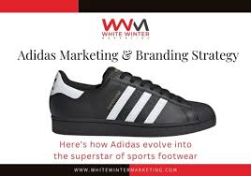
Storytelling:
Adidas excels at creating emotional connections through digital campaigns that tell stories of triumph and overcome adversity.
- Aspirational Messaging:
The "Impossible is Nothing" campaign embodies the brand's message of belief and overcoming challenges, inspiring millions worldwide.
- Iconic Visual Identity:
The three-stripe logo, originally symbolizing a mountain and challenges, is a vital and recognizable element of the brand.
- Influencer Marketing:
The brand partners with major athletes, celebrities, and social media influencers to promote products and connect with various fan bases.
- Digital Transformation:
Adidas invests heavily in digital platforms, leveraging social media, influencer marketing, and even augmented reality (AR) for immersive experiences.
- Sponsorships:
A long-standing strategy involves sponsoring major sports teams and events to enhance brand visibility and build loyalty.
- Sustainability and Inclusivity:
Adidas positions itself as a socially responsible entity by incorporating sustainability into its messaging and focusing on women in sports and diversity initiatives.
- Cultural Relevance:
The brand aims to create local relevance by incorporating cultural elements into its marketing and product design, such as specific strategies for the Indian market.
- Product Focus:
While leveraging technology, Adidas also emphasizes product functionality, breathability, and comfort to appeal to its target audience.

4.COMPANY WEBSITE ANALYSIS:
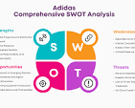
The adidas company website serves as a central e-commerce platform, focusing on performance and style with a user-friendly interface, detailed product information, and customer support. It effectively drives sales with strong direct and organic search traffic, complemented by digital marketing efforts and a dedicated loyalty program. The site highlights the brand's commitment to innovation and sustainability, offering specialized products for various sports while providing a seamless online shopping experience.

Key Features and Strengths
  - User-Centric Design:
The website prioritizes customer experience with an intuitive design, detailed product descriptions, and easy navigation for different sports and styles.
  - Strong E-commerce Presence:
adidas.com is a significant sales channel, attracting a large number of visits and demonstrating robust performance with strong engagement metrics.
  - Digital Marketing Integration:
The site is a core part of Adidas's digital strategy, supported by a significant portion of the marketing budget dedicated to digital and social campaigns.
  - Loyalty Programs:
Programs like the adiClub (in the US) enhance customer loyalty by offering rewards, points, and exclusive access to products.
  - Sustainability Focus:
The website prominently features Adidas's commitment to sustainability, including the use of sustainable cotton and efforts to eliminate single-use plastics.
  - Brand Reinforcement:
The site reinforces brand values by highlighting innovative technology, inspiring athletes, and promoting a message of collective movement and empowerment.
Performance and Traffic
  - High Traffic Volume:
In August 2025, adidas.com saw 29.57 million visits, indicating a strong user base.
  - Top Traffic Sources:
Direct traffic and organic search are the leading sources, driving the majority of desktop visits.
  - Customer Engagement:
The average session duration of 6 minutes and 18 seconds reflects good user engagement on the site.
Areas for Potential Improvement
  - Delivery Times:
Longer delivery times in remote areas and for customized orders can be a point of frustration for some customers.
  - Customer Reviews:
The inability for customers to review products on the website may be a missed opportunity for social proof and feedback.
  - Pricing Competitiveness:
While strong on innovation, Adidas faces challenges in competing on price with local competitors, which may affect certain customer segments, though the website primarily targets those seeking performance and style.

5.MARKET SHARE VALUES:

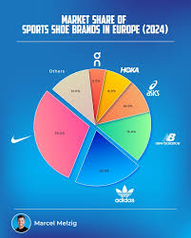

Adidas holds a significant global sportswear market share, reportedly around 8.9% as of early 2025, having grown from 8.2% in late 2024. Its overall sales saw a 19% increase in the quarter ending December and a 12% increase for 2024 as a whole. The company's market capitalization was approximately $37.35 billion USD as of September 16, 2025, according to Macrotrends.
Key Market Performance Indicators

- Market Share:
Adidas's share of the global sportswear market grew to 8.9% in the period ending December 2024, up from 8.2% previously, according to YouTube analysis of financial news.
- Sales Growth:
The company experienced a 19% increase in sales for the quarter ending December and a 12% increase for the full year 2024.
- Market Capitalization:
Adidas's market cap was approximately $37.35 billion USD as of September 16, 2025, according to Macrotrends.
- Nike Market Share:
In comparison, Nike's global market share decreased to 14.1% from 15.2% in 2023, while Nike's sales were down 9% in the quarter ending November 30, 2024.
Revenue and Profitability
- Revenue:
Adidas generated approximately €21.43 billion in revenue for 2023, according to Statista.
- Operating Profit:
The company's operating profit was €1.280 billion in the first nine months of 2024, with an operating margin of 7.2%. This represents a significant increase from €646 million with a 3.9% margin in the same period in 2023.
Shareholder and Geographic Information
- Institutional Shareholdings:
As of December 2023, the North American market accounted for 34% of institutional shareholdings, reports the adidas Group annual report.
- Global Distribution:
Other large geographical areas for institutional holdings include the UK and Ireland with 21%, identified German investors with 14%, and other continental European countries with 27%.

6.GEOGRAPHICAL CAL SPREAD:

Adidas generates significant net sales across major geographical regions, with Europe leading in 2024 at nearly 32%, followed by North America (22%), Greater China (15%), and Asia-Pacific (14%). The company maintains a robust global distribution network of owned retail stores, franchise stores, wholesale partners, and e-commerce platforms to reach consumers worldwide.
Geographical Sales Distribution (2024):
- Europe: Nearly 32% of net sales.
- North America: 22% of net sales.
- Greater China: 15% of net sales.
- Asia-Pacific: 14% of net sales.

Distribution Channels:
- Owned Retail Stores: ~1,900 locations worldwide.
- Franchise Stores: ~15,000 mono-branded franchise stores.
- Wholesale: Reaching consumers through approximately 150,000 wholesale doors.
- E-commerce: Available in 67 countries and through Statista's digital partnerships.
Key Aspects of Adidas's Geographical Strategy:
- Global Reach:
Adidas's products are available in over 160 countries through various channels.
- Direct-to-Consumer (DTC) Model:
The brand utilizes its own retail stores, e-commerce platforms, and proprietary apps to strengthen customer engagement and offer personalized experiences.
- Wholesale Partnerships:
Adidas collaborates with wholesale partners, including department store concessions and factory outlets, to ensure broad product accessibility.
- Digital Expansion:
The company has made substantial investments in e-commerce to serve both developed and emerging markets effectively.

7.DEMAND AND SUPPLY:

Adidas currently experiences strong consumer demand across all its sales channels, leading to positive financial results and growth in wholesale and direct-to-consumer (DTC) sales, though this sometimes presents a challenge in meeting supply. The company's strategy includes investment in R&D for new products to evolve the brand, a focus on direct-to-consumer (DTC) growth through its own stores and e-commerce, and a global supply chain with independent manufacturing partners, primarily in Asia.

Demand Factors:
- Strong Brand Momentum:
Recent double-digit growth in wholesale and DTC revenue indicates high consumer interest and sell-through rates.
- Product Innovation:
Investment in Research & Development (R&D) for new, state-of-the-art apparel and footwear helps drive demand for the brand.
- Marketing & Events:
Campaigns like "You Got This" and active participation in major sports events, such as the Euro 2024 and Copa América, boost brand presence and sales.

- Target Market Appeal:
Adidas targets sports enthusiasts, athletes, and those who integrate fitness into their lifestyle, ensuring consistent demand.
Supply Chain & Production:
- Independent Manufacturing Partners:
Adidas relies on a global network of independent manufacturing partners, mainly in Asia, for cost-efficient, high-volume production of footwear and apparel.
- Product Segmentation:
The company produces a variety of products, with apparel and footwear being its biggest segments, alongside accessories and gear.
- Logistical & Inventory Management:
Adidas faces challenges in managing demand fluctuations and disruptions from natural disasters or geopolitical events, which can lead to overstocking or stockouts.
- Inventory Reduction:
The company actively works to reduce inventory levels, with recent results showing a decrease in working capital as a percentage of sales.
Key Strategic Directions:
- DTC Growth:
A significant focus is placed on growing direct-to-consumer (DTC) sales through own retail stores and e-commerce platforms.
- Supply-Demand Balancing:
While demand is strong, the company aims to balance this with supply to avoid shortages and improve efficiency.
- Market Focus:
Key markets for Adidas include North America and Greater China, contributing significantly to overall sales.

8.FACTORS AFFECTING DEMAND AND SUPPLY:

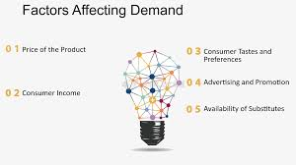

Adidas's supply and demand are affected by external factors like global economic conditions, geopolitical tensions, natural disasters, and logistics disruptions that impact supply chain reliability. On the demand side, factors include consumer income and sentiment, strong brand reputation, the popularity of specific product launches, and competition from other brands. Adidas uses data analytics and AI to forecast demand and improve supply chain efficiency, while also maintaining a diversified supplier base and flexible production to adapt to challenges.
Factors Affecting Supply
- Supply Chain Disruptions:
Geopolitical events, pandemics, natural disasters, and port congestion can significantly disrupt Adidas's production and delivery of goods.
- Supplier Reliability & Diversification:
Dependence on a limited number of suppliers can lead to issues. Adidas is working to diversify its supplier base to maintain control over its global operations.
- Logistics Complexities:
Global transportation delays, regulatory hurdles, and the need for multiple transportation modes to prevent disruptions add to logistical challenges.
- Production Agility:
Adidas uses flexible design and regional production strategies to adapt to changes in demand and reduce lead times.
- Technology Integration:
Digital tools like AI and data analytics help manage the supply chain, improve visibility, and enable quicker responses to potential problems.
Factors Affecting Demand
- Brand Reputation and Marketing:
A strong brand image, supported by successful product launches, drives consumer demand for Adidas products.
- Economic Conditions:
Consumer income and economic sentiment directly affect demand. As Adidas products can be considered luxury items, demand is sensitive to changes in disposable income.
- Competition:
Adidas faces strong competition from other sportswear brands, which influences its market share and product demand.
- Product Innovation and Customization:
Launching innovative and customizable products can capture consumer interest and boost demand.
- Regional Market Needs:
Strategic product offerings tailored to specific countries and regions, such as Asian markets, can enhance appeal and sales.
- Direct-to-Consumer (DTC) Growth:
Strong performance in its direct-to-consumer channels, like e-commerce and retail stores, indicates robust consumer demand.
How Adidas Manages Supply and Demand
- Data-Driven Forecasting:
Adidas uses data analytics and AI to forecast demand more accurately and manage inventory effectively.
- Flexible Supply Chain:
The company implements flexible designs, fallback transportation solutions, and dynamic capacity management to adapt to disruptions.
- Diversified Supply Base:
A more diversified supplier base enhances supply chain resilience and coordination.
- Risk Mitigation:
Adidas has implemented business continuity plans, fallback solutions, and insurance coverage to manage risks from disruptions and geopolitical events.

9. BUSSINESS FUNCTION CARRIED OUT ONLINE:

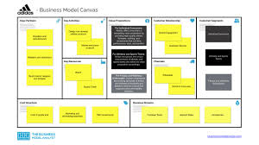

Adidas operates through core business functions including Product & Marketing, Global Operations, and Finance, supported by corporate functions like Human Resources, IT, and Legal to support its mission of creating high-quality, innovative sports and lifestyle products. Key activities involve product design and development, supply chain management, digital engagement, brand building through storytelling and athlete endorsements, and sales via wholesale and direct-to-consumer (DTC) channels.

Core Business Functions
- Product & Marketing:
Develops and markets innovative apparel, sportswear, and accessories, focusing on performance and lifestyle products that resonate with consumers and setting sports and lifestyle trends.
- Global Operations:
Manages the supply chain, including sourcing and production, and focuses on product development, sustainability initiatives, and digital innovation to create value for the business.
- Finance:
Oversees the company's financial operations, including managing finances, treasury, and taxes, to achieve financial goals like increasing net income and providing attractive investment opportunities.
Supporting & Corporate Functions

- Human Resources:
Focuses on employee well-being, diversity, engagement, and talent development, recognizing people as essential to the company's success and brand desire.
- IT (Information Technology):
Supports operations and business functions with technological solutions.
- Legal:
Manages legal affairs and ensures compliance with regulations and policies.
- Sustainability:
Integrates sustainable practices, from sourcing recycled materials to promoting human rights and fair labour across the supply chain.
Key Activities & Strategies
- Innovation:
Continuously develops new, high-performance products and technologies.
- Digital Engagement:
Utilizes social media, email, and the adiClub membership program to build direct relationships with consumers and gather feedback.
- Branding:
Creates brand heat by telling inspiring stories and collaborating with high-profile athletes.
- Sales & Distribution:
Manages sales through wholesale partners and a growing direct-to-consumer (DTC) channel, including own retail stores and e-commerce.

10. INCREMENTAL INNOVATION



Adidas employs incremental innovation to enhance existing products through continuous improvements, such as its ongoing use of sustainable materials like recycled polyester and performance-enhancing technologies like Boost and Lightstrike. This strategy also includes adopting new digital tools, like its virtual fitting app for enhanced customer experience, and integrating innovative manufacturing techniques, such as Strung uppers for footwear, into its supply chain to deliver better quality, more sustainable, and high-performance products.
Sustainable Materials
- Recycled Content:
Adidas has successfully replaced all virgin polyester with recycled polyester in its products, surpassing its 2024 target.
- Parley for the Oceans:
Through this collaboration, Adidas uses plastic waste intercepted from oceans and coastal communities to create footwear, including the 100% recyclable FUTURECRAFT.LOOP shoe.
- Waste Repurposing:
The brand is also working to repurpose other waste materials, like agricultural residues and discarded clothing, into new products and packaging.
Performance Technologies
- Boost & Lightstrike:
Adidas utilizes technology platforms like Boost (a cushioning system) and Lightstrike (a lightweight foam) to enhance the performance of its athletic footwear.
- 4DFWD:
The brand's 4DFWD 2 running shoe features a unique bowtie-shaped lattice midsole designed to transform vertical pressure into horizontal force, improving propulsion.
- Strung Uppers:
Adidas has developed and implemented Strung technology, a material born from running and adapted for football, for its high-performance shoes.
Digital & Manufacturing Innovation
- Augmented Reality:
Adidas integrated a virtual sneaker fitting tool into its iOS application, allowing users to virtually try on shoes like the Alphaedge 4D.
- Digital Twins:
The company is exploring the use of digital twins of its products to accelerate and increase the efficiency of its product development process.
- Cloud Infrastructure:
By adopting cloud platforms, Adidas gains the scalability and elasticity needed to support its growing e-commerce business and respond to peak demand.
Broader Strategy
- Collaboration:
Adidas collaborates with a wide range of partners, including athletes, universities, research organizations, and other innovators, to gather insights and develop new solutions.
- R&D Integration:
While the ambitious Speed Factory project was closed due to high costs and inflexibility, its technologies and lessons learned were integrated into existing manufacturing operations, improving efficiency and enabling innovation at scale.

11. DISCRIPTIVE INNOVATION:

Adidas employs disruptive innovation through sustainability initiatives like Parley Ocean Plastic and Futurecraft Loop (fully recyclable shoes), manufacturing advancements like Speedfactories using additive manufacturing (3D printing) to enable localized production and rapid prototyping, and digital transformation including a data mesh architecture for better data access and engagement models like the Creators Club membership program. These innovations disrupt the traditional sportswear supply chain, accelerate product development, and foster sustainable practices.

- Speed factories & 3D Printing:

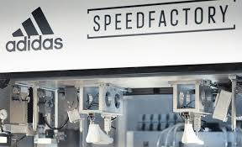
Adidas has leveraged additive manufacturing (3D printing) in its Speedfactories to create high-performance footwear, allowing for rapid prototyping, customization, and localized production. This directly challenges traditional, high-volume, globalized manufacturing models.
- Futurecraft:
The Futurecraft 4D platform uses light and oxygen (Digital Light Synthesis) for unique, high-performance midsoles. Futurecraft Loop is a fully recyclable performance shoe made from a single material, disrupting the concept of end-of-life products.
- Sustainable Materials:
The use of Parley Ocean Plastic transforms ocean plastic into performance products, aligning performance with global environmental needs. The Infinite Hoodie is another example of a commercially produced, 100% recyclable performance garment, according to adidas.
Digital Transformation
- Data Mesh Architecture:
Adidas transitioned from a monolithic data system to a data mesh architecture, which decentralizes and democratizes data access, enabling more agile and data-driven decision-making.
- Customer Engagement:
Initiatives like the Creators Club provide a digitally-enabled membership program that rewards loyal consumers with exclusive access to events and limited-edition products.
Strategic Partnerships & Marketing

- Collaborations:
Adidas's collaboration with Willy Chavarria and Wales Bonner brings unique perspectives and elevates streetwear aesthetics, challenging traditional sportswear norms.

Marketing Innovations:
The "Ghost Drop" is an example of a disruptive marketing concept that uses mystery raffles to engage consumers with limited-edition items.
Overall Impact
These disruptive innovations allow Adidas to create products faster, reduce waste, personalize offerings, and engage with consumers in new ways, creating a significant shift in the traditional sportswear industry.

CHAPTER 2 INTERNAL ENVIRONMENT

1.PROMOTORS AND MANAGEMENT ETHOCS

Adidas's promoters and management ethos is built upon core values of Courage, Ownership, Innovation, Teamplay, Integrity, and Respect, which guide their strategies and operations. This ethos emphasizes human-centered work, fostering talent development and well-being to drive performance and brand success. Adidas is deeply rooted in sport, with a purpose to change lives through sport, and aims to be the industry leader by creating and selling the best sports products in a sustainable and inclusive way.

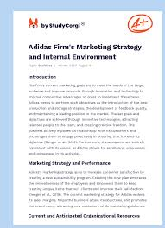

Core Values & Purpose
- Six Core Values:
The company's culture is structured around six core values: Courage, Ownership, Innovation, Teamplay, Integrity, and Respect.
- Purpose-Driven:
Adidas operates with a purpose to "Through sport, we have the power to change lives," which informs all company activities.
- Mission:
Their mission is to be the world's best sports brand by producing high-quality products, offering excellent customer experiences, and promoting sustainability.

Management & Culture
- People Focus:
Adidas prioritizes its people, creating a supportive culture that enhances their performance, well-being, and personal growth.
- Strategic Alignment:
The core values influence strategic decisions and define the company's work ethic and overall brand ethos.
- Internal Management:
Management uses a structured performance measurement system, benchmarking results against competitors and conducting detailed analyses to identify areas for optimization.
Sustainability & Human Rights
- Commitment to Sustainability:
Adidas is dedicated to creating a more sustainable world and integrates this commitment into product development and operations.
- Human Rights Policy:
The company has a comprehensive Human Rights Policy, aligned with international guidelines like the UN Guiding Principles, to ensure dignity, fairness, and equality across its value chain.
- Due Diligence:
Adidas conducts due diligence in its operations and supply chains to identify and address human rights risks, including forced labour and child labour.
Brand Identity & Marketing
- Sport-Centric:
The brand's identity is rooted in sport, focusing on technical products for athletes and sports enthusiasts.
- Innovation and Performance:
Adidas emphasizes performance, innovation, credibility, and sustainability in its product development and marketing.
- Digital Focus:
Recognizing the importance of the digital age, Adidas invests significantly in its digital presence to improve its overall marketing strategy and reach consumers effectively.

2.BACKGROUND OF PROMOTORS GROUP (TOP 5 AND BOTTOM 5 PLAYER)



Adidas's promoter group is rooted in its founder, Adolf "Adi" Dassler, who started the company in 1949 after a falling out with his brother, Rudolf Dassler, and their previous family shoe business, Dassler Brothers Shoe Factory. After their split, Rudolf founded Puma, while Adi established Adidas, later transforming it into a corporation in 1989 and acquiring Reebok in 2006. The company's early success was driven by Adi's innovative shoe designs, exemplified by Jesse Owens' performance at the 1936 Berlin Olympics, and the German national soccer team's 1954 World Cup victory.
The Dassler Brothers and the Founding of Adidas
- 1920s:
Adi Dassler began making athletic shoes in his mother's laundry room in Herzogenaurach, Germany.
- 1924:
His brother, Rudolf Dassler, joined him, and they established the Dassler Brothers Shoe Factory (Gebrüder Dassler Schuhfabrik).
- 1936 Berlin Olympics:
Jesse Owens wore Adi Dassler's custom shoes, gaining international recognition for the company.
- Post-WWII Split:
After a disagreement, the brothers parted ways.

- 1949:
Adi Dassler formally founded Adidas, with the registration of the Adolf Dassler adidas Sportschuhfabrik in August. His brother, Rudolf, founded Puma.
Growth and Transformation
- 1950s-1970s: Adidas expanded through athlete and team sponsorships, notably the German national soccer team's 1954 World Cup win, solidifying its global presence.
- 1971: The iconic Stan Smith shoe was introduced.
- 1989: Adidas was transformed into a public limited company (Aktiengesellschaft).
- 1990s: The company experienced a transition period before returning to its core focus on product quality and launching the EQUIPMENT line.
- 1995: Adidas shares were listed on the stock market.
- 2005: Adidas acquired Reebok, significantly expanding its global footprint and creating a formidable competitor to Nike.
Ongoing Legacy
- 2006: The Reebok acquisition was completed, integrating the brands into the new adidas Group.
- Current Leadership: Bjørn Gulden has served as the CEO since January 1, 2023.
- Company Identity: Adidas remains committed to its purpose of empowering individuals and uniting people through sport, guided by the principle of creating the best sports products in the world.

3.BRIEF PROFILE OF CMDS, CEOS

Adidas's current CEO is Bjørn Gulden, a Norwegian national who took the helm in January 2023. A former professional football player, Gulden brings extensive experience in the sportswear industry, having previously served as CEO for Puma and Pandora. He holds a Bachelor of Business Administration and an MBA, and has held various executive roles at other companies, including Deichmann and Helly Hansen.
Bjørn Gulden
- Role: Chief Executive Officer of adidas AG
- Nationality: Norwegian
- Born: 1965
- Education: Bachelor of Business Administration (University of Rogaland, Norway) and an MBA (Babson Graduate School of Business, USA)
- Previous Roles:
  - CEO of PUMA SE
  - CEO of Pandora
  - Managing Director of Deichmann Group
  - President and Chief Executive Officer of Rack Room Shoes
  - Senior Vice President of Apparel and Accessories at Adidas (1992-1999)

4.CRS POLICY

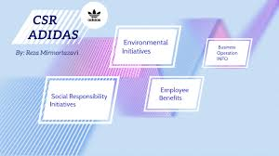

Adidas's Corporate Social Responsibility (CSR) policy is centered on three key areas: environmental sustainability, human rights, and employee and community development. The company focuses on reducing its environmental footprint, promoting fair labour practices through its supply chain, and investing in community engagement and education. Key initiatives include using sustainable materials, eliminating plastic packaging, and partnering with organizations to address global challenges.

Key Pillars of Adidas's CSR Policy
- Environmental Sustainability:
  - Sustainable Materials: Adidas aims to use 100% recycled polyester and sources only sustainably produced cotton through initiatives like the Better Cotton Initiative.
  - Circular Economy: The company is working on developing circular business practices and innovative materials to reduce waste.
  - Plastic Reduction: Adidas has eliminated plastic bags in its stores and is working to make its packaging plastic-free.
  - Decarbonization: The company has set targets to achieve climate neutrality by 2050 by working with suppliers to reduce carbon emissions.

- Human Rights & Responsible Production:
  - Ethical Supply Chain: Adidas works to uphold human rights and fair labour practices in its supply chain by setting strict Workplace Standards and conducting rigorous monitoring.
  - Worker Well-being: The company aims to ensure safe working conditions and fair treatment for all workers.
- Employee & Community Engagement:
  - Community Investment: Adidas supports community-based projects and partnerships, such as its work with the "Common Goal" organization to promote climate action and community development through sport.
  - Diversity and Inclusion: The company fosters an inclusive environment for its employees and promotes education and empowerment through various learning opportunities.

5. CORPORATE GOVERNANCE


Corporate governance is the system by which companies are directed and controlled. Boards of directors are responsible for the governance of their companies. The shareholders' role in governance is to appoint the directors and the auditors and to satisfy themselves that an appropriate governance structure is in place.
DIFFERENT BETWEEN INITIATIVE OF SOCIAL INCLUSION AND EVIRONMENT AND CONSERVATION
Adidas addresses social inclusion and environmental conservation through initiatives like the Adidas Foundation, which focuses on anti-discrimination, sport for development, and inclusive access to sports, and by committing to reducing its environmental footprint through circularity programs, sustainable material sourcing, and waste reduction strategies. Key environmental efforts include using recycled materials, phasing out coal in the supply chain, achieving high waste diversion rates, and a commitment to a deforestation- and conversion-free (DCF) leather supply chain by 2030.
Social Inclusion Initiatives
- Adidas Foundation:


This new initiative consolidates social impact efforts, with a focus on people through programs for anti-discrimination, sport for development, and inclusive access to sports for all.
- Diversity, Equity, and Inclusion (DEI):
Adidas aims to increase female representation in leadership positions and holds inclusive events like the "Global Week of Inclusion" to promote diversity in areas such as age, disability, and mental health, according to its 2022 annual report.
- Community Engagement:
The company is committed to making a social impact in its communities through its purpose of "Through sport, we have the power to change lives".
- Collaboration with NGOs:
Adidas partners with organizations like the Greensole Foundation to provide resources to children in need.
Environmental Conservation Initiatives
- Circularity and Waste Reduction:
Adidas is implementing waste management guidelines to improve material segregation, increase recycling, and divert non-recyclable waste to waste-to-energy solutions. They also achieve high waste diversion rates within their own operations and supplier facilities.
- Sustainable Materials:
Efforts include transitioning 99% of polyester to recycled polyester, optimizing packaging with recycled and certified materials, and reducing the use of hazardous chemicals.
- Climate Action:
Adidas supports the transition to lower-carbon alternatives, process electrification, and lower-temperature assembly to reduce greenhouse gas emissions in its supply chain.
- Biodiversity Protection:
The company works to protect biodiversity by improving the sourcing of natural materials like cotton, leather, and rubber, and by ensuring they do not source materials from endangered species.
- Deforestation-Free Supply Chain:
By 2030, Adidas aims for a deforestation- and conversion-free (DCF) bovine leather supply chain, supported by initiatives to improve traceability and certification for leather.
- Circular Products:
Adidas has developed innovative circular products, such as the Future Craft Loop shoe, which is 100% recyclable and made from returned and recycled materials.

CHAPTER 3 EXTERNAL ENVIRONMENT

1.CONTROLLING MINISTRY OF INDUSTRY

The phrase "ADIDAS CONTROLLING MINISTRY OF INDUSTRY" is a misunderstanding; there is no "Ministry of Industry" controlling Adidas, but rather Adidas operates in India under the jurisdiction of relevant Indian government bodies, including seeking approval from the Department for Promotion of Industry and Internal Trade (DPIIT) for Foreign Direct Investment (FDI) and adhering to general and industry-specific regulations. The search results show Adidas has been engaged with the Indian government regarding FDI, the establishment of company-owned retail, and the setup of an innovation hub in Tamil Nadu, as seen in various news articles and official notices.
Adidas and Indian Government Interaction
- FDI Approvals:
Adidas has approached the Indian government for FDI to operate its own retail stores in India, a process that involved applications to the Department of Industrial Policy & Promotion (DIPP), now known as DPIIT.
- Retail Expansion:
In 2016, Adidas received government approval to set up company-owned retail stores and an e-commerce venture in India, following a revised policy on manufacturing and retail.
- Innovation Hub:
Adidas is also establishing a Global Capability Center (GCC) in Tamil Nadu, which is a strategic move to support global operations from India, as reported by The Economic Times.
- Regulatory Compliance:
As a global corporation, Adidas operates within the legal framework of India and is subject to its various regulatory bodies, although these are not summarized as a single "Ministry of Industry" controlling them.
Key Government Bodies Involved
- Department for Promotion of Industry and Internal Trade (DPIIT):
This department handles industrial policy and promotion, including approvals for FDI.
- National Company Law Tribunal (NCLT):
This body handles corporate law matters, such as the amalgamation of companies, as seen in a case involving Adidas India Private Limited.
In summary, Adidas follows standard business and legal procedures to operate in India, rather than being directly controlled by a single "Ministry of Industry".

2.REGULATORY POLICY OF THE STATE

Adidas does not have a single "policy of the state" but rather complies with a range of state and national regulations, and engages with governments on policy matters like trade, environmental standards, and human rights. Key areas of state regulatory engagement include product safety standards, with a focus on avoiding defective products and complying with chemical restrictions in regions like the EU. The company also has policies on corporate social responsibility (CSR), such as its India CSR policy, which includes contributing to national funds and local development.
Key Areas of Regulatory Policy Engagement
  - Product Safety:
Adidas must manage risks associated with selling defective products and comply with increasing regulatory demands, such as restrictions on certain chemicals and import regulations.
  - Human Rights & Environment:
The company is committed to human rights and environmental protection and engages with governments to address violations and negative environmental impacts.
  - Trade and Intellectual Property:
Adidas monitors and is influenced by policies in these areas, engaging in lobbying after careful evaluation to ensure alignment with its values.
  - Corporate Social Responsibility (CSR):
In India, for example, Adidas engages in CSR activities like rural development and contributing to national funds.
How Adidas Addresses Regulatory Policy
  - Government Affairs Teams:
Adidas has dedicated teams that monitor and engage in lobbying efforts on regulatory issues.
  - Product Safety Network:
The company has a network to monitor regulatory compliance activities related to product safety across its business units.

  - Lobbying and Engagement:
Adidas engages with governments, but only after careful evaluation to ensure its activities align with the company's values.
  - Membership in Business Associations:
Adidas collaborates with national and international organizations, which provide platforms to monitor regulatory developments and voice policy interests.
Specific Regulations Mentioned
  - EU Regulations:
The EU's increasing regulatory requirements on chemicals, imports, and sustainability are a specific challenge for Adidas.
  - Privacy Policies:
Adidas updates its privacy policies and provides information for residents of specific US states (e.g., California, Colorado) who may have additional rights.
  - Engagement & Governance - adidas Group
Policy development: * adidas actively supports human rights and environmental protection. Therefore, our concerns over violation.

3.NATIONAL AND GLOBAL LEVEL IMPACTS
Adidas has a vast national and global impact, influencing the sports apparel market through its diverse product offerings, significant R&D investments, and strategic focus on key markets like North America and Greater China. The company impacts global consumers by adapting to trends in sports and fashion and engaging with them through initiatives like Run for the Oceans. Its influence also extends to workers in its global supply chain and local communities through efforts to improve working conditions and foster social and environmental responsibility.
Economic & Market Impact
- Global Sales & Markets:
Adidas is a major player in the global sportswear market, with significant portions of its annual sales coming from regions like North America and Greater China.
- Product Innovation:
The company invests heavily in research and development to create new sportswear lines, including performance products and sports-inspired fashion, adapting to evolving consumer demand.
Supply Chain Presence:
Adidas works with numerous independent supplier facilities across many countries, particularly in the Asia-Pacific region, directly impacting employment and economies in these locations.
- Strategic Market Entry:
Adidas identifies key strategic markets like India, recognizing the growing health consciousness and increased sporting success of consumers as opportunities for growth.
Social & Environmental Impact
- Sustainability Initiatives:
Through programs like the Run for the Oceans initiative, Adidas uses its platform to raise awareness about environmental issues, such as ocean pollution, and encourages positive action.
- Community Engagement:
The company works with local communities on initiatives aimed at driving meaningful social and environmental impact.
- Supply Chain Responsibility:
Adidas is committed to ensuring decent work conditions in its global supply chain, focusing on preventing child labor and protecting juvenile workers by strengthening human resources systems at the factory level.
- Corporate Governance:
The company has established policies and a Global Privacy Management Policy to manage risks related to consumer privacy and ensure responsible marketing practices.
Cultural Impact
- Fusion of Sport and Fashion:
Adidas plays a significant role in shaping trends that merge athletic performance with lifestyle and fashion, influencing consumer choices globally.
- Uniting Consumers:
Through major sporting events and global movements, Adidas helps to unite people by leveraging the unifying power of sports and creating platforms for collective action.
- Athlete Endorsement:
By sponsoring top athletes and sports events, Adidas builds its brand and inspires consumers by showcasing the performance and cultural relevance of its products, as seen in its sponsorship of top marathon runners.

4.ACTION BY SEBI


There are no recent records of the Securities and Exchange Board of India (SEBI) taking action directly against Adidas. However, a different search result from 2012 indicates that Adidas itself was investigating irregularities in its Reebok India operations, which may have involved SEBI or other legal actions. The other results discuss SEBI actions against financial influencers, a raid on Avadhut Sathe's academy, and news regarding Adidas stock performance on the day it was mentioned in a list alongside other companies with the most negative impacts from earnings and the broader market.
Here's a breakdown of the relevant information:
- No Direct SEBI Action:
There are no current or recent reports of SEBI taking action against Adidas.
- Past Adidas Action:
In 2012, Adidas announced plans to take legal action following financial irregularities found in its Reebok India operations. This was an action by Adidas and not by SEBI against Adidas.
- Recent Mention of Adidas:
A recent Economic Times article from July 2025 mentions Adidas in the context of European shares falling and the company's stock sinking, but this does not indicate any action by SEBI.
- Related to Financial Influencers:
Other results focus on SEBI's actions against financial influencers like Avadhut Sathe, not Adidas.
In summary, any connection between Adidas and SEBI appears to be a misunderstanding or a reference to older, unrelated events.

5.COMPETITION COMMISSION OF INDIA



The Competition Commission of India (CCI) dismissed a complaint against Adidas and Reebok in 2014, finding that while the Adidas group might hold a dominant position in the premium sports goods market, their actions did not constitute an abuse of dominance under Section 4 of the Competition Act. The CCI noted that the alleged unfair agreement was formed before the Adidas group was formed and continued unchanged after its formation, failing to show a violation of competition law.

Case Overview
- Complaint: Filed by Om Datt Sharma, alleging abuse of dominant position by Adidas AG and Reebok (as a group) in the premium sports goods market in Noida.
- Date of Order: The CCI passed its order on May 13, 2014.
CCI's Reasoning
- No Violation of Section 4:
The Commission stated that even though the Adidas AG Group appeared to hold a dominant position, the facts on record showed no violation of Section 4 of the Competition Act.
- Timing of Agreement:
A key point was that the alleged unfair agreement predated the formation of the dominant group (which came into existence in 2005) and continued under the same terms after its formation. This limited the grounds for finding an abuse of dominance by the group .

CHAPTER 4 FINANCIALS

1.PROFITABILITY REVENUE MARGINS:

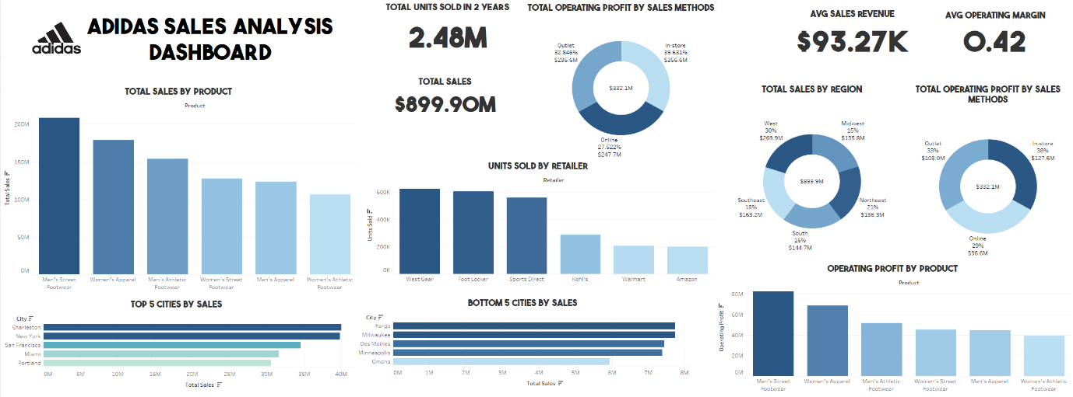
Adidas reported a significant gross profit margin improvement to 51.9% in the first half of 2025, up from 51.0% in the first half of 2024, driven by lower product and freight costs and reduced discounting. For the full year 2024, the gross margin was 50.8%, a substantial increase from 47.5% in 2023, also due to lower costs and reduced discounting. Recent adidas Group reports suggest strong consumer interest and double-digit growth in the Adidas brand, aiming for a 10% operating margin target long-term.
Key Profitability Metrics
- Gross Profit Margin:
The percentage of revenue remaining after deducting the cost of goods sold (COGS).
  - H1 2025: 51.9%
  - Full Year 2024: 50.8%
  - Full Year 2023: 47.5%
- Operating Profit Margin:
The percentage of revenue remaining after deducting operating expenses but before interest and taxes.
  - Trailing Twelve Months (TTM): 7.39% (as per MLQ.ai, though latest official figures may differ)
  - Target: Long-term goal of 10%
- Net Profit Margin:
The percentage of revenue remaining after all expenses, including taxes, have been deducted.
  - H1 2025: 4.17%
  - Full Year 2024: 1.71%
Factors Influencing Profitability
- Positive Drivers:
  - Reduced Costs: Lower product and freight costs significantly contributed to margin expansion.
  - Less Discounting: A reduction in promotional activities helped improve gross margins.
  - Strong Brand Performance: The Adidas brand is seeing strong consumer and retailer interest, with double-digit growth.
- Headwinds:
  - Currency Effects: Unfavourable currency impacts have negatively weighed on the gross margin.
  - Tariffs: Early negative impacts from increased tariffs were observed in the first half of 2025.
Revenue Performance
- Strong Growth:
Adidas has reported strong revenue growth, exceeding expectations in the first quarter of 2025.
- Quarterly Performance:
Analysts expected a revenue increase of 4.5% year-on-year to €5.6 billion for the second quarter of 2025.
- Double-Digit Growth:
The Adidas brand achieved double-digit growth in 2024, a key factor in improving operating profit.

2.TRENDS AND CHANGES ADAPTED BY INDUSTRY
Adidas has adapted by focusing on sustainable innovation, integrating recycled and bio-based materials and developing circular products through initiatives like "Made to be Remade". The company is also leveraging AI and automation in its manufacturing for agility, leading to drastically reduced lead times and enhanced quality control. Additionally, Adidas is undergoing a major digital transformation, expanding its e-commerce and data-driven marketing strategies to drive growth and engagement in the digital landscape.
Sustainability and Circularity
- Eco-friendly Materials:
Adidas is committed to using low-impact materials, incorporating recycled ocean plastic through its Parley partnership and exploring bio-based alternatives.
- Product Circularity:
Initiatives like the Futurecraft Loop shoe and the "Made to be Remade" program and take-back programs aim to create products that can be repeatedly remade, aligning with a circular economy model.
- Climate Goals:
The company has set a goal for climate neutrality in its operations by 2025 and plans to use 90% low-impact materials by the same year.
Manufacturing and Technology
- AI and Automation:
Adidas is using AI in its "Speed Factories" to enable rapid production of limited editions and respond quickly to demand, which boosts profitability and brand cachet.
- Reduced Lead Times:
Through localized and automated production, Adidas has significantly cut down the time it takes for products to go from design to customer, improving responsiveness to market trends.
- Enhanced Quality:
Automated processes and real-time analytics help ensure consistent product quality and minimize defects.
Digital Transformation
- E-commerce Growth:
To adapt to changing consumer behaviors, especially during the pandemic, Adidas scaled up its e-commerce operations to become a primary sales channel.
- Data-Driven Marketing:
The company is investing in strategies to enhance personalization, optimize mobile experiences, and leverage social media to better engage customers and drive growth.
- Cloud Infrastructure:
Adidas has built a flexible, cloud-based infrastructure to handle spikes in online demand and manage complex e-commerce systems, ensuring seamless customer experiences.
Product Portfolio and Marketing

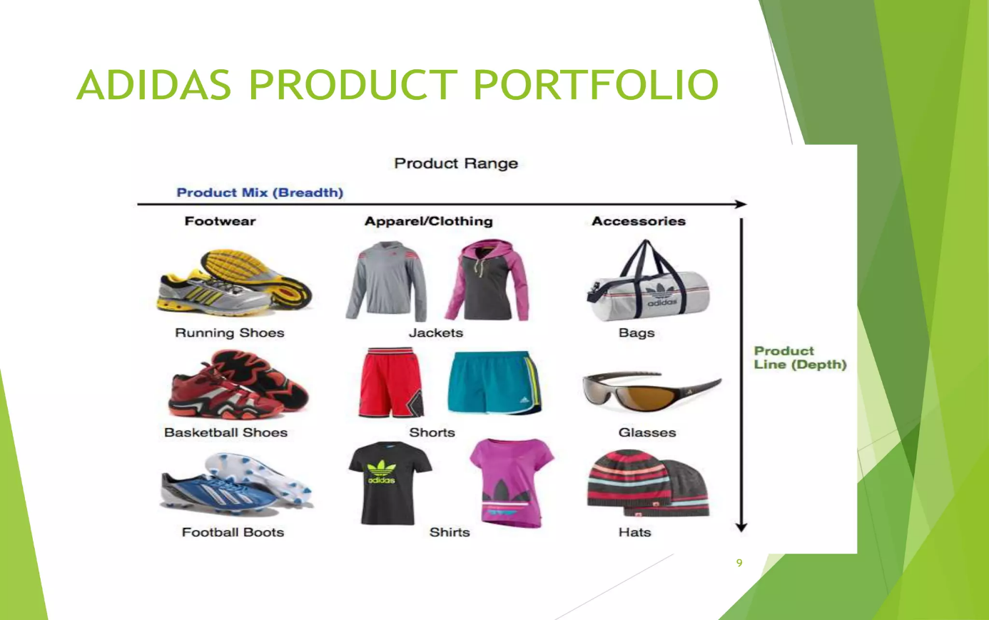

- Sport-Inspired Lifestyle:
Adidas continues to draw on its rich history and archives to create popular "sport-inspired" or "athleisure" products that appeal to a wide consumer base.
- Brand Collaborations:
The company partners with celebrities, such as Beyoncé for the Ivy Park collection, to create buzz and maintain relevance with its target audience.
- Targeted Marketing:
Beyond traditional advertising, Adidas is increasingly focusing on influencer marketing and social media to promote products and build excitement.
3.SICK PLAYER AND THEIR TURN AROUND STRATEGY
Adidas' "turnaround strategy," led by CEO Bjørn Gulden, involves quick decision-making, a focus on athletes to drive engagement, and empowering internal teams to prioritize product quality over strict sales targets. This brand reset returned Adidas to its athletic roots, successfully leveraging tailwinds like renewed consumer interest in its Samba and Terrace sneakers and achieving strong financial results, with a significant rise in stock price after discontinuing the Yeezy line.
Key Elements of the Turnaround Strategy
- Quick Decision-Making:
The company adopted a more agile approach, enabling faster responses to market changes and consumer preferences.
- Athlete-Centric Approach:
Adidas leveraged the power of athletes to inspire and engage consumers, reconnecting with its core purpose of serving sports.
- Empowered Teams & Quality Focus:
Internal teams were given more freedom to focus on the quality and innovation of their output, shifting away from the pressure of meeting strict sales targets.
- Brand Reset:
The strategy was a fundamental "brand reset," moving the company back to its authentic athletic roots and innovative spirit.
- Leveraging Market Tailwinds:
The strategy capitalized on existing trends, such as a resurgence in consumer interest for classic models like the Samba and Terrace sneakers.
- Financial Success:
This renewed focus led to strong financial results, including increased revenue, profit, and a doubling of the stock price after the discontinuation of the Yeezy line.

4.FACTORS CONTRIBUTING TO COST
Factors contributing to the cost of Adidas products include the use of high-quality materials, innovative shoe technology, and extensive marketing, including celebrity endorsements and digital campaigns. Additionally, the company's strategy of premium pricing, which targets higher-end customers, and investments in a robust, quality-focused supply chain also contribute to the overall cost.
Product-Related Factors
- High-Quality Materials and Technology:
Adidas uses premium materials and invests in advanced technology to create high-performance, durable, and comfortable products.
- Product Innovation:
Continuous investment in new designs and technologies to create unique products adds to the cost.
Marketing and Branding
- Celebrity Endorsements:
Partnering with influential athletes and sports teams like Aitana Bonmatí and the French Rugby Federation increases marketing and overall product costs.
- Global Brand Campaigns:
Significant investments in large-scale marketing campaigns and event support, such as the UEFA EURO 2024 and the Olympic Games, drive up expenses.
- Digital Transformation:
A growing focus on digital marketing and e-commerce to reach a wider audience requires substantial investment.
Supply Chain and Operations
- Quality Supply Chain:
Building and maintaining a strong, reliable supply chain ensures consistent product quality, which can be a costly but essential investment.
- Operating Overhead:
General operating expenses and overhead costs related to running a global enterprise also contribute to the final price.

Pricing and Market Strategy
- Premium Pricing Strategy:
Adidas often employs a skimming pricing strategy, especially for innovative new products, to target high-end customers who are willing to pay more for quality and exclusivity.
- Brand Value:
The strength of the Adidas brand, market dominance, and the associated consumer desire for the "three stripes" logo allow for higher pricing.

5.RATIO ANALYSIS OF FINANVIALDATA FOR THE LAST 5 YEARS

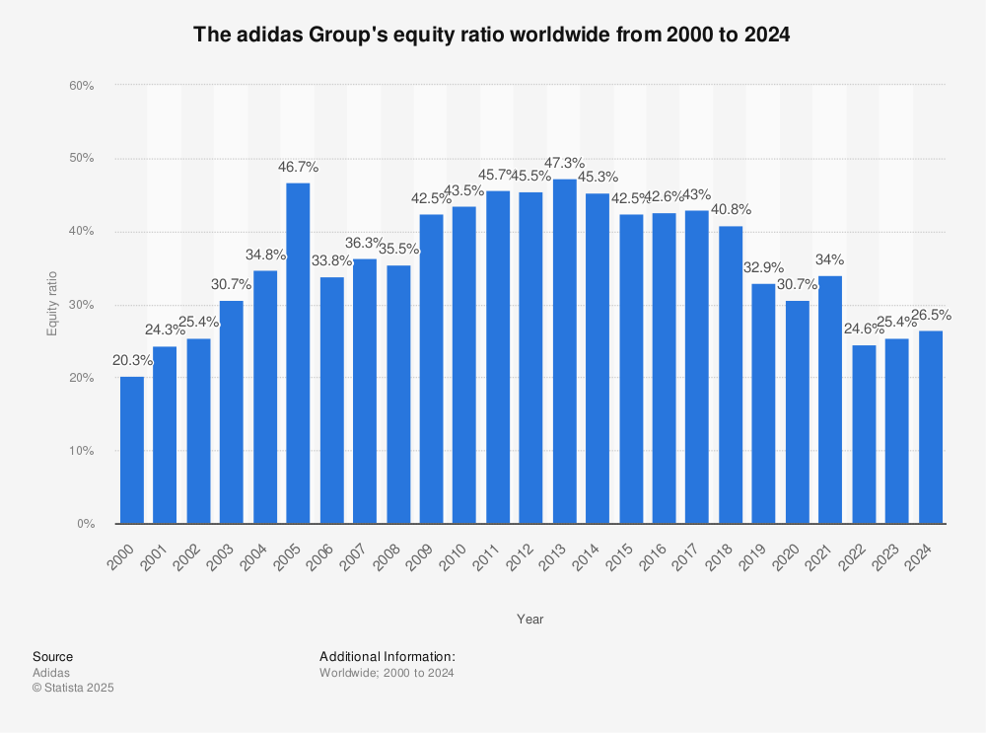

Adidas's 5-year trend analysis shows generally improving liquidity, with the Quick Ratio increasing from 0.78 to 1.25 between 2019 and the most recent quarter (2024), and the Cash Ratio peaking in 2020 before declining to a low in 2022 and recovering somewhat by 2024. The Debt-to-Equity ratio has fluctuated significantly, with a recent increase in debt relative to equity, indicating potential risks despite overall financial strength. The company demonstrates strong EBIT coverage of its interest payments, but a general decline in operational efficiency is noted by a decrease in Asset Turnover.
Liquidity Ratios
- Quick Ratio:
This ratio, which measures a company's ability to meet its short-term obligations with its most liquid assets, has shown a strong upward trend.
  - 2019: 0.78
  - 2020: 0.88
  - 2021: 1.11
  - Most Recent Quarter (2024): 1.25
- Cash Ratio:
Adidas's cash ratio peaked in 2020 and then saw a significant decline in 2022, with a subsequent rebound in 2023 and 2024.
  - 2020: 0.5x
  - 2022: 0.1x
  - 2024: 0.3x
Leverage Ratios
- Debt-to-Equity Ratio: This ratio has been volatile, with recent data from 2020 to 2024 showing an increasing trend in debt.
  - 2020: 0.91
  - 2021: 0.71
  - Most Recent Data: Increased from 43.5% to 47% over the past five years.
Efficiency Ratios
- Asset Turnover: This ratio measures how efficiently a company uses its assets to generate sales, and it has shown a downward trend.
  - Most Recent Quarter (2024): 0.79
  - Five-Year Average: 0.64
Profitability Ratios (Not Detailed, but Mentioned)
- Return on Equity (ROE):
Not provided in the search results but is a key profitability ratio for Adidas.
- Earnings Per Share (EPS):
A key indicator of profitability, also not fully detailed for a 5-year trend in these results.
Key Takeaways
- Improved Liquidity:
Adidas's short-term solvency improved significantly from 2019 to the most recent quarter, as indicated by the strong growth in the Quick Ratio.
- Increased Debt-to-Equity:
The recent increase in the debt-to-equity ratio could signal higher financial risk, but it is currently well-covered by operating cash flow and EBIT.
- Declining Operational Efficiency:
The decrease in the asset turnover ratio suggests that Adidas's efficiency in generating sales from its assets has declined over the period.

CHAPTER 5 RECENT DEVELOPMENT



1.IMPACT OF LATEST FISCAL POLICY
Adidas faces rising product costs and potential US customer demand disruption due to new US tariffs on goods from key manufacturing nations like Vietnam and Indonesia, potentially increasing costs by €200 million and leading to price hikes for American consumers. The company is expected to incur these costs in the coming months, even as it reported strong gross margins in its latest financial results, driven by reduced discounting and lower freight costs. Adidas is expected to provide further details on its reaction to these tariffs and their long-term impact.
Key Impacts:
- Increased Costs:
The tariffs are expected to add a significant financial burden to Adidas, potentially increasing their annual costs by €200 million.
- Product Price Increases:
To offset the higher costs from the tariffs, Adidas plans to raise prices for American customers.

- Supply Chain Vulnerability:
The tariffs highlight Adidas's reliance on manufacturing in Vietnam and Indonesia, which are significantly affected by the new US trade agreements and tariff structures.
- Potential Demand Impact:
Adidas is still assessing the effect on customer demand and whether major inflation caused by these tariffs will affect sales.
Context:
- Manufacturing Reliance:
A significant portion of Adidas's products, including popular items, are manufactured in countries now subject to US tariffs, such as Vietnam and Indonesia.
- Financial Performance:
Despite the looming tariff costs, the company recently reported a strong Q2 performance with increased gross margins, partly due to lower discounting and freight expenses.
Future Outlook:
- Adidas expects the tariff impact to become more significant in the upcoming quarters.
- The company's full-year operating profit forecast remains within its projected range, but further statements are anticipated to clarify the long-term strategy to address these tariffs.

2.ANALYSIS FOR LATEST EXIM POLICY
An analysis of the latest Exim policies' impact on Adidas would focus on increased compliance burdens due to India's mandatory Quality Control Orders (QCOs) for imported goods like footwear and apparel, which require factory certifications and could affect sourcing, along with trade policies that create risks from supply chain disruptions due to geopolitical instability or natural disasters. Adidas needs to adapt to these policy shifts, leverage existing strengths in innovation and global markets, and manage risks like currency fluctuations and intensified environmental regulations to maintain its competitive edge and ensure resilient growth.
Impact of India's Latest Exim Policies
- Mandatory Quality Control Orders (QCOs):
The Indian government has implemented stringent new QCOs for imported goods, including apparel and footwear.

- Factory Certification Challenge:
Adidas must ensure its overseas factories are audited and approved by India's Bureau of Indian Standards (BIS) to comply with these QCOs, a significant logistical and bureaucratic undertaking.
- Risk of Import Ban:
A failed factory audit can result in a ban on importing products from that facility, posing a risk to Adidas's supply chain.
- Increased Consumer Protection:
The QCOs aim to protect Indian consumers from poor-quality goods and to level the playing field for local manufacturers.
Adidas's Strategic Response and Considerations
- Adaptability and Agility:
Adidas must remain adaptable to shifting trade policies and regulations to navigate the complex landscape of global trade.
- Compliance and Logistics:
The company needs to invest in systems to manage the complex process of factory audits, testing, and certification to comply with new quality standards in key markets like India.
- Supply Chain Diversification:
To mitigate risks from geopolitical instability, such as port congestion or trade tensions, Adidas may need to reevaluate its sourcing and production locations and have robust business continuity plans.
- Leveraging Innovation and Sustainability:
Adidas can leverage its ability to innovate and align with growing social values, such as sustainability, as a competitive differentiator and a way to create new opportunities.
- Geopolitical and Economic Risk Management:
Adidas must continue to monitor potential threats, including climate-related natural disasters, port congestion, and economic downturns, and implement dynamic solutions to manage disruptions and maintain profitability.

3.KEY ALLIANCES IN THE PAST 5YEARS

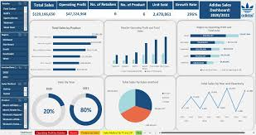

In the last five years, Adidas' key partnerships have focused on innovation and sustainability, notably through collaborations with Parley for the Oceans, Allbirds, and Spinnova for eco-friendly materials. The brand also strengthened its market presence with the BCCI partnership in India and continued its luxury fashion collaborations, such as the one with Gucci. Adidas also partnered with Amazon for its Buy with Prime program, marking a significant move into e-commerce integration.
Innovation & Sustainability Partnerships
- Parley for the Oceans:
Adidas has a landmark partnership with Parley to drive eco-innovation and create a global movement for the oceans through sports. This includes the use of recycled ocean plastic in products and initiatives to phase out single-use plastics.
- Allbirds:
Adidas collaborated with the footwear pioneer Allbirds to develop products like the Adizero x Allbirds 2.94 KG COe.
- Spinnova:
The partnership with Spinnova led to the creation of the adidas Terrex HS1 hoodie, made from wood-based fibers.
- Infinited Fiber Company:
Adidas actively seeks partnerships with brands like Infinited Fiber Company that share their sustainability mission.
Market & E-commerce Partnerships
- BCCI (Board of Control for Cricket in India):
In India, the partnership with the BCCI has been highly successful, with high jersey sales and record engagement from associated campaigns.
- Amazon Buy with Prime:
Adidas has joined Amazon's Buy with Prime program, which allows consumers to use their Prime benefits when shopping on other platforms, enhancing its e-commerce presence.
Luxury and Fashion Collaborations
- Gucci: The collaboration with Gucci combines the heritage of both brands, producing collections that blend athletic staples with leisurewear.
Other Strategic Alignments
- Research & Technology Companies:
Adidas invests in and collaborates with various companies, universities, and research organizations, such as BASF and Carbon, to develop groundbreaking technologies and processes.
- Sustainability Frameworks:
The company aligns its efforts with globally recognized frameworks by collaborating with organizations like the Better Cotton Initiative, Canopy, and the Fashion Industry Charter for Climate Action.

4.TECHNOLOGICAL DEVELOPMENT


Adidas has developed a new technology - Strung - the first textile technology that transforms athlete data into dynamic performance material. The company says it wants this to be the most data-informed textile, based on foot anatomy and athlete movement. The first shoe being made using the new technology is expected to be available by late 2021/early 2022.
The new textile innovation changes footwear is created. Every thread in Strung is individually selected and data-mapped for a seamless, lightweight fit, the company says. It has designed the first concept, Future craft.Strung, to illustrate Strung’s capability. It combines high-res creation technologies Adidas 4D and Strung, as the industry’s first fully athlete data-coded shoe.
“Futurecraft is our incubator for innovations and technologies designed to shape the future of sport, a platform to develop “what’s next” and solving issues facing athletes, sports and the world at large,” the company says.
“Our material tech challenge was very clear - we wanted to make something where we could place the yarns in any direction, to go beyond what existing textile creation methods are capable of. Getting that base Strung textile to work and function as we want is and will continue be a challenge. Strung is not knitting and it’s not weaving: it hasn’t existed before,” the company says.
The company has created the first-of-its-kind concept shoe to provide a new experience of short-distance training runs at 5m/s or faster. Two adidas runners were identified as experts in this run and provided both motion capture and ongoing feedback to support development. The upper has a lightweight cocooned feel and fit, locking the heel to prevent slip, with stiffer and stronger red threads placed at the midfoot, toe-box, and heel (where the foot needs support), and suppler yellow threads in the forefoot for flexibility. These threads blend each of those features together within the material to provide precise fit and support through the gait cycle.
The midsole is the company’s most radical Adidas 4D lattice design to date - featuring a new shape to cater for forefoot strikers. The heel has been minimised to remove weight and the rubber outsole is specifically engineered to provide traction just where needed, resulting in an extremely minimalist midsole.
“Probably the most exciting thing about Strung is that we’re still in the early stages of developing it – the ongoing testing will be fundamental to what we do next, but more important than that is the trajectory of consumers and athletes – what do they want next and how are their needs changing?” the company says and adds “Strung is a milestone that has the potential to transform the way athletes work with designers, engineers and sports scientists. The ultimate aim is for it to be a cross-category platform that serves multiple sports. We’ve started with running but that’s just the beginning. We want this to be the most data-informed textile (based on foot anatomy and athlete movement), and we’re planning to make the first shoe available late 2021/early 2022.”
Technology can achieve wonderful things, but it can only achieve the right things if it’s informed by human behaviour, it says. “It is this open approach that has guided us on the Strung journey so far, and it is this same approach that we believe will help us on the road ahead.”
5.EMERGING FIRST GENERATION ENTREPRENEURS


There are no public Adidas initiatives specifically labeled for "Emerging First Generation Entrepreneurs" at the time of this response; however, Adidas's founder, Adi Dassler, is an example of a first-generation entrepreneur. The company has also supported other entrepreneurial efforts through its partnerships with initiatives like Deed, which uses technology to make social good accessible, and by establishing a Global Capability Center (GCC) in India to develop its innovation and e-commerce platforms.

Adi Dassler: The Founding Entrepreneur
- Humble Beginnings:Adolf "Adi" Dassler started making shoes in his mother's laundry room after World War I.
- Innovator:He was an innovative designer and a pioneering promoter of sports endorsements.
- Company Foundation:In 1949, he established the new Adidas company with 47 employees, focusing on creating the best equipment for athletes.
- Global Success:His company grew from a small workshop into a global sportswear giant.
Other Entrepreneurial Connections
- Deed and Deevee Kashi:Adidas has partnered with Deed and entrepreneur Deevee Kashi, who uses technology to connect celebrities, influencers, and corporations with social good initiatives. This collaboration promotes a new generation of socially engaged entrepreneurs.
- Adidas India's GCC:Adidas is establishing its first GCC in Tamil Nadu, India, to enhance its global capabilities. This move supports technological and product development, creating opportunities for individuals to contribute to the company's innovation.
Finding More Information
For information on Adidas's current initiatives or to explore opportunities for aspiring entrepreneurs, visit the official adidas Group website or check professional networking sites like Forbes for relevant articles and features.

